Word template for proseminar ‘automatic bicycle’
Received 10/29/2015 12:04:00 Revised 10/29/2015 12:04:00

A. Uthor
Matriculation Number: 00000000
Technische Universität München, Garching, Department of Informatics
Boltzmannstr. 3, 85748 Garching, Germany
e-mail address: name@in.tum.de

Please do briefly summarize the topic of your review, the main findings and your conclusions (max. 200 words)

Keywords: maximum 5 keywords

- Introduction
Describe your topic and your expectations, e.g. a hypothesis you might have about the topic, questions you think are relevant. Briefly describe your search strategy (e.g. keywords, search engines you used, number of results)
- Literature review
Summarize key statements of relevant articles you found with citations (Newton, 1704).
- Discussion
How do the statements you found matching your expectation. Are they contradicting each other or confirming each other? Are there rivaling approaches? What are the main findings, what are open questions?

- Conlusion
State the three most important findings of your review.
Tables
Table 1. Example of a Double-Column Table
Column 1 | Column 2 | Column 3 | Column 4 | Column 5 | Column 6 | Column 7 | Column 8

Figures
In case your manuscript contains figures, they are typically placed in one column inside the respective section. A large figure might span two columns. As you most likely take a figure from another paper, do not forget to state your source!
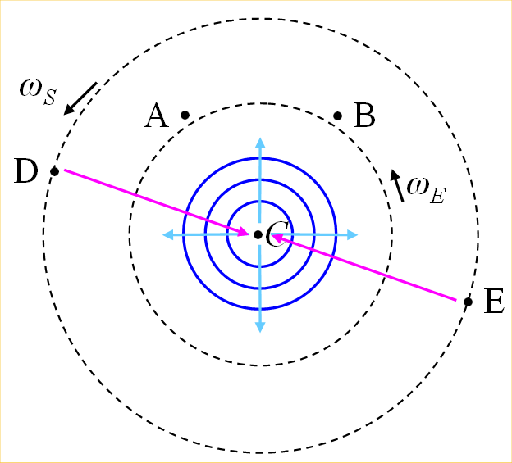
FIG. 1. (Color online) A central clock, orbited by one or more clocks. Figure captions use Figure style. The figure image itself uses picture style.

acknowledgements
If somebody did substantially help you with this review, e.g. discuss with you or point you to relevant sources, acknowledge him here.
Bibliography
Newton, I. (1704). Opticks: or a treatise of the reflexions, refractions, inflexions and colours of light.

